The heat of a pepper is measured using Scoville units: The relatively mild poblano weighs in at about 1,500 SCU, while the superhot habañero packs a whopping 250,000 SCUs or more. If you want the flavor without the mouth-scorching fire, remove the seeds and interior ribs from a chile before cooking it. It's also a good idea to have dairy products, such as milk or yogurt, on hand—they contain casein, which helps neutralize capsaicin, the chemical that gives chiles their heat. And remember: Always protect your skin by wearing gloves when handling hot peppers.

A Visual Guide to Peppers

Get to know your sweet and spicy peppers

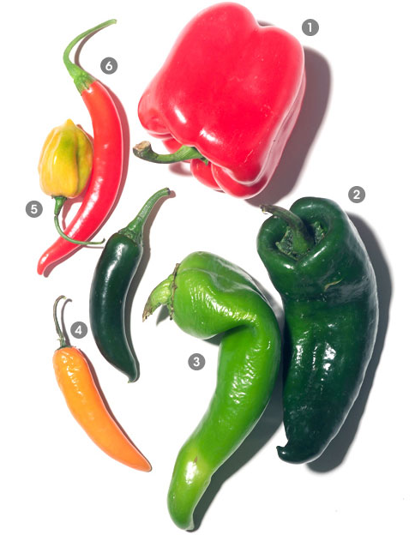
The word "pepper" refers to members of the genus Capsicum, which includes hot varieties, also known as chile peppers, and sweet varieties, such as the bell pepper. Until the arrival of Spanish and Portuguese explorers in the New World, peppers grew only in Latin America. Along with corn, tomatoes, and beans, the Europeans brought back some of the peppers and on their travels introduced the plant to the rest of the world, where it took off like wildfire. Truly international in their appeal, peppers have become integral to cuisines across the world, from Mexico to Thailand, the Congo to India, and from Hungary to Tunisia.
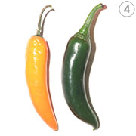
Bell Pepper
Alternate Names: Green pepper, red pepper, sweet bell pepper, capsicum
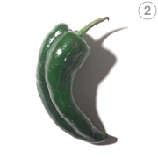
Characteristics: Relatively large in size, the bell-shaped pepper in its immature state is green with a slightly bitter flavor. As it matures, it turns bright red and becomes sweeter. You can also find yellow, orange, white, pink, and even purple varieties. With their high water content, bell peppers will add moisture to any dish. They're also great for adding color.
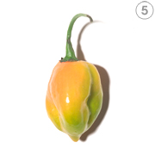
Scoville heat units: 0
Poblano
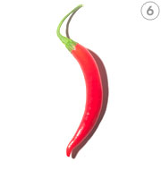
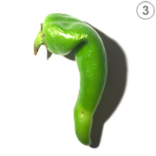
Characteristics: Somewhat large and heart-shaped, the mildly hot poblano is common in Mexican dishes such as chiles rellenos. At maturity, the poblano turns dark red-brown and can be dried, at which point it's referred to as an ancho or mulato. If smoked and dried, it becomes a chipotle, which is often used in mole sauces. Scoville heat units: 1,000 to 2,000
Anaheim
Alternate Names: California green chile, chile verde, New Mexican chile
Characteristics: This long pepper is relatively mild and very versatile. When mature, the Anaheim turns deep red and are referred to a chile Colorado or California red chile. Anaheims are popular in salsas and dishes from the American Southwest. Scoville heat units: 500 to 2,500

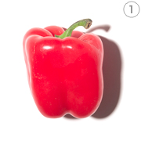
Serrano
Characteristics: Just a couple of inches long, with a tapered end, this small pepper packs quite a bit of heat. Beware: The smaller the pepper, the hotter it is. When ripe, serranos are red or yellowish orange—they can be cooked in both their ripe and unripe states. Serranos are common in Mexican and Thai cooking. Scoville heat units: 6,000 to 23,000
Habañero
Characteristics: Small and bulbous, this chile, in the same family as the Scotch bonnet, is one of the hottest on the Scoville scale. If you can get past the heat, habañeros also have a fruity flavor. They're popular on Mexico's Yucatan Peninsula and in the Caribbean, where they're used to make hot sauces. Scoville heat units: 100,000 to 350,000, and higher
Cayenne
Alternate Names: Finger chile, Ginnie pepper, and bird pepper
Characteristics: Slender and tapered, this chile is probably most familiar in its dried, ground form—the powder known as cayenne pepper. cayenne pepper. Ground cayenne pepper is a main ingredient in the chili powder that flavors Tex-Mex dishes such as chili con carne. Scoville heat units: 30,000 to 50,000

